**Embedding Text across Surveys & Contact Lists:**

**A Simple Qualtrics Guide**

**Paul M. Garrett**

**01/05/2020**

# Displaying text from file

## File creation

To display text in Qualtrics from a file, you must have a CSV file with a mandatory ‘Email’ column header, and as many additional optional headers as you like. For example, the following Figure displays an Email heading, a ‘SEMA’ ID heading, and a ‘KeyWords’ heading. Each row represents a participant and each participant must have an email field.

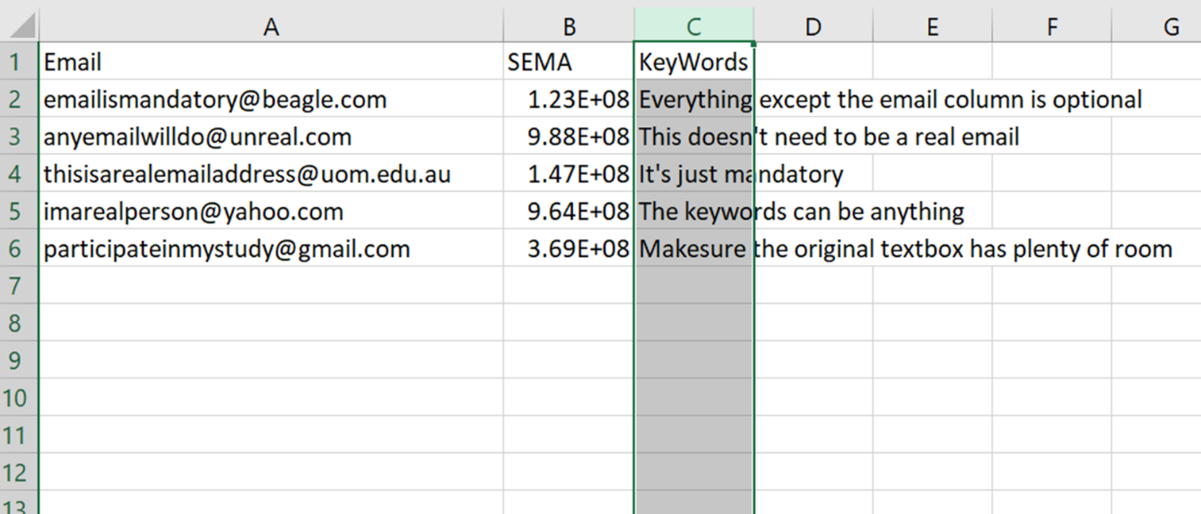

## Adding File to Contacts

To add your file for display in Qualtrics, create a new ***Contact List***. This can be found as a tab on the main menu. Once you create and name a contact list, (e.g., ‘Demo_SecreteKeywords’), select the ‘import from a file’ option. Your Contact list will be automatically populated with the fields in the CSV file (see below Figure). Click add contacts to finalize your contact list.

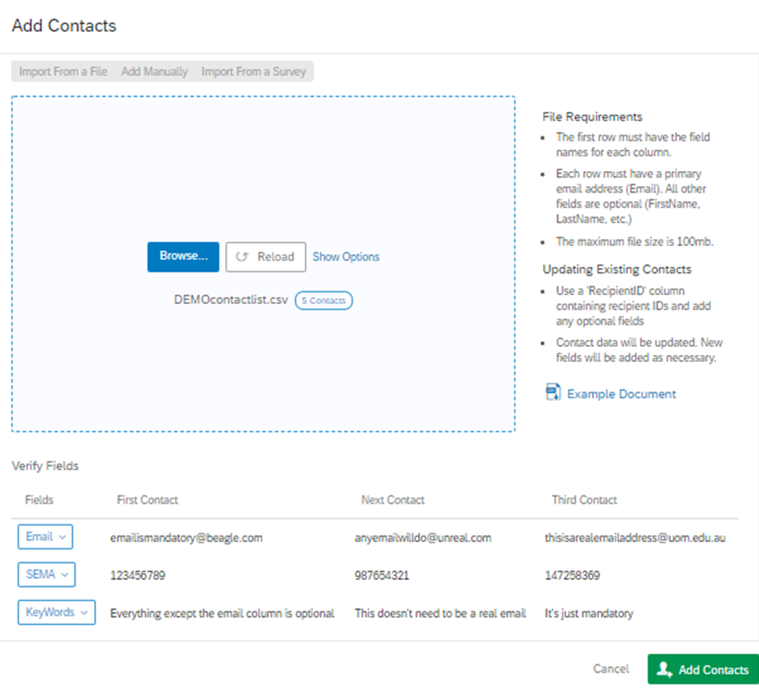

You can now view any of your contacts and their information by clicking on them. Your contact list will only display the default columns: First Name, Last Name, & Email; however, by clicking on each participant you can see further details: ‘SEMA’ and ‘Keyword’ (See Figure below)

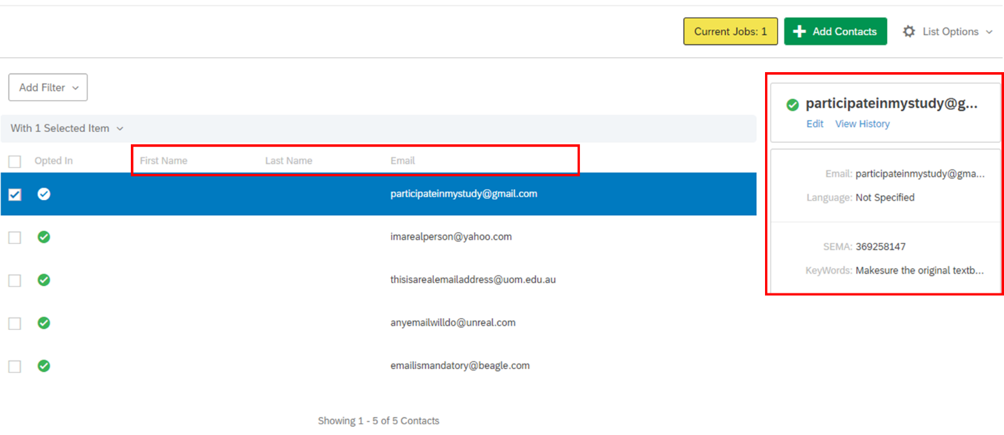

You are now ready to import your contact information into a Qualtrics survey. Please skip ahead to the page titled **‘Importing contact information into a survey’** or continue reading to see how to automatically create a contact list from another Qualtrics survey.

# Creating a contact list from a separate Qualtrics survey

This is a two-stage Qualtrics survey design. In the first instance participants complete an intake survey where they provide identifying information, (e.g., a Prolific or SEMA ID, or an email), and answer a question that needs to be indexed in a follow-up survey, (e.g., key words). In the second instance, participants complete a follow-up survey where information they answered previously is presented, (e.g., text display), or evaluated (e.g., a score of previous items).

The advantage of this system is that the contact list is automatically updated with each incoming participant. The downside is that any mistake in the identifying field, (e.g., their SEMA ID), will stop them from viewing their information in the follow up survey. This system works best when information is imported to the intake survey automatically, for example, when using an ID embedded in the survey URL that can be accessed as an embedded data field (e.g., the SEMA ID embedded in the following study URL [www.qualtrics.com/MyQualtricsSurveyLink?SEMA=123456789](http://www.qualtrics.com/MyQualtricsSurveyLink?SEMA=123456789)).

## Create initial data fields

In the following examples, we will be carrying over an Email address from one survey to another, and using this to display KeyWords to our participants. We start by creating the intake questionnaire. Here, we ask participants to provide a name and email address – only the email field will be important to us: this will be our authenticating/identifying information.

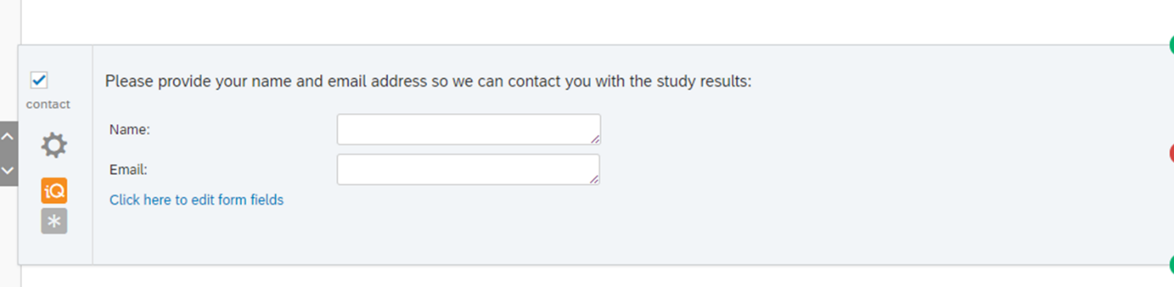

We also ask for the participant’s secret Key Words. These key words will be displayed in the follow up Qualtrics survey. Importantly, we will use the email address to make sure the right key words are provided to each participant.

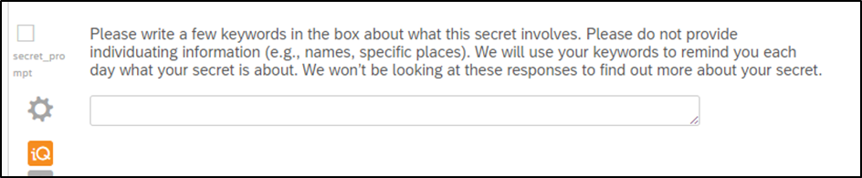

We then set embedded data fields for our primary measures. This step might not be necessary (you may be able to do the next trigger step directly from the questions), however, it does make everything after this much easier. Below, I set the embedded data fields ‘EmailAddress’ and ‘KeyWords’ indexing their previous responses in the survey.

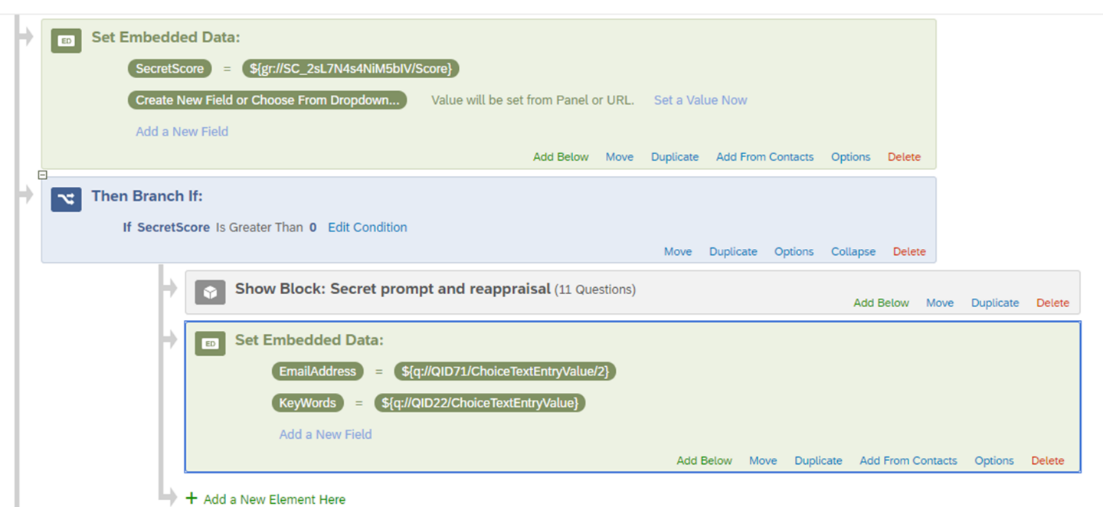

## Create a contact list

Next we create a contact list that we can auto-populate with the above embedded data fields. Returning to the main Qualtrics menu, select create a contact list. Then, when prompted, enter a name for your contact list (e.g., ‘DEMO_AutoPopulateKeywords’), and skip any instructions to import data. Once your contact list has been created, return to your survey.

## Automatically fill your contact list

To automatically fill your contact list, return to your survey, select ‘Tools’ > ‘Triggers’ > ‘Contact List Triggers’. Add your contact list, for example, ‘DEMO_AutoPopulateKeywords’. Then, add your contact information: in this example, I will add the embedded data field ‘EmailAddress’ to the ‘Email’ field and the embedded data field ‘KeyWords’ to the newly created data field’. See example below.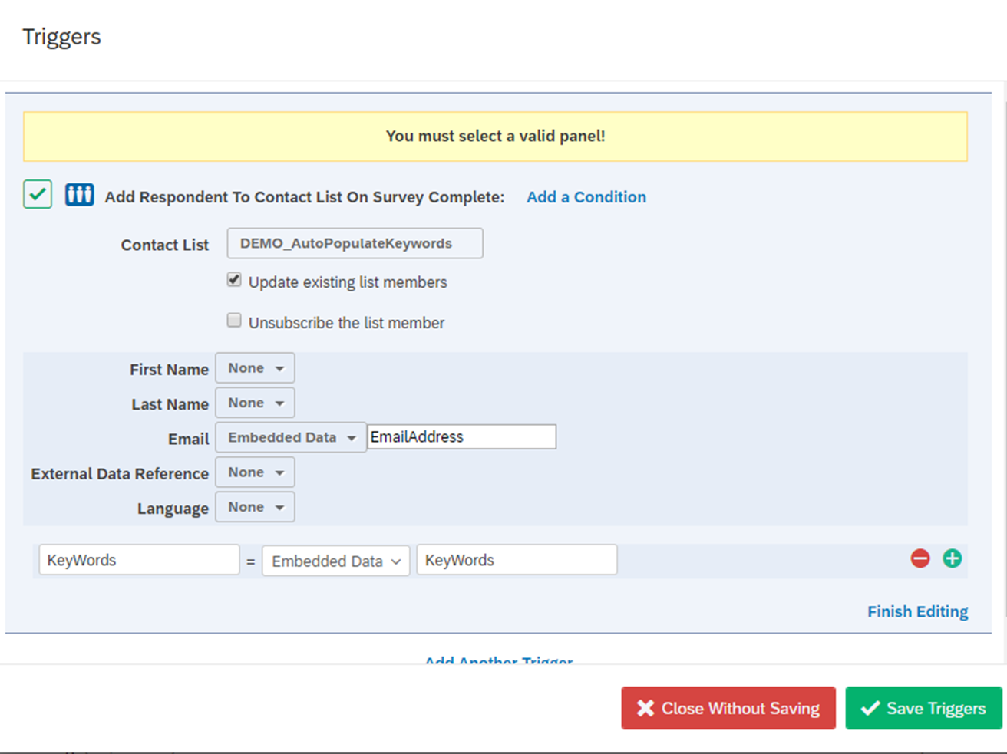

## Test your experiment

Next, pilot your experiment providing information to your contact list fields: in this example, email address and secret key words. Once you have piloted your experiment, check your contact list from the Qualtrics main menu. You should see your information recorded in the contact list (see Figure below for an example of what this would look like).

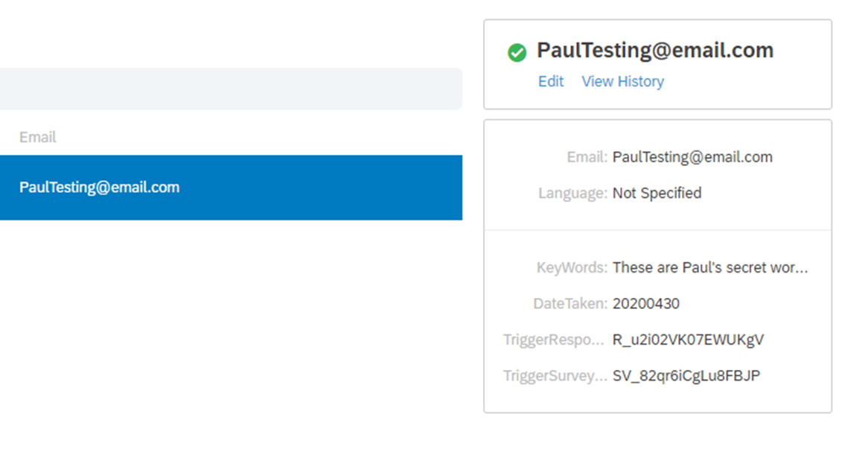

Now you are ready to import your data from the contact list into a follow-up survey. See the next section ‘**Importing contact information into a survey**’ for further instructions.

# Importing contact information into a survey

Now you have a contact list, you need to ensure that the right contact (participant) sees the right information. To do this, we use a Qualtrics authenticator block. In the below example, I will be authenticating participants based upon their Email address, but the exact same could be done using a SEMA ID or Prolific ID.

I first create an Authenticator Block in the survey flow. Then, I add contact information using my previously created contact list ‘DEMO_AutoPopulateKeywords’ (from the second section of this document). I then ensure that ‘Email’ is selected as the authenticating field (of course you would change this for the relevant ID information, e.g., SEMA or Prolific).

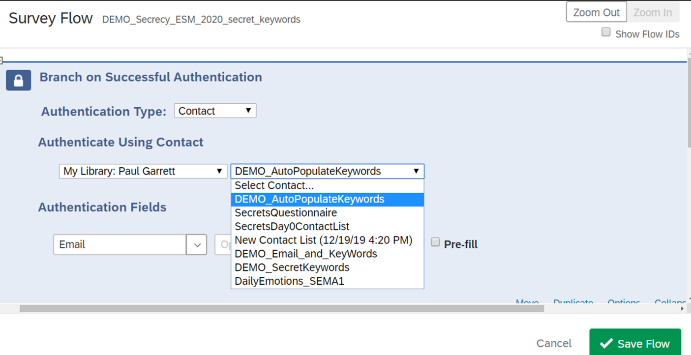

The authenticator is intended to allow a single response by each participant; however, often we want participants to be able to reuse the link as often as they would like. To this end we can access the authenticator options. Here we can set the max limit to 999, change the text displayed by the authenticator, and allow participants to return to the authenticator whenever they wish (see next Figure).

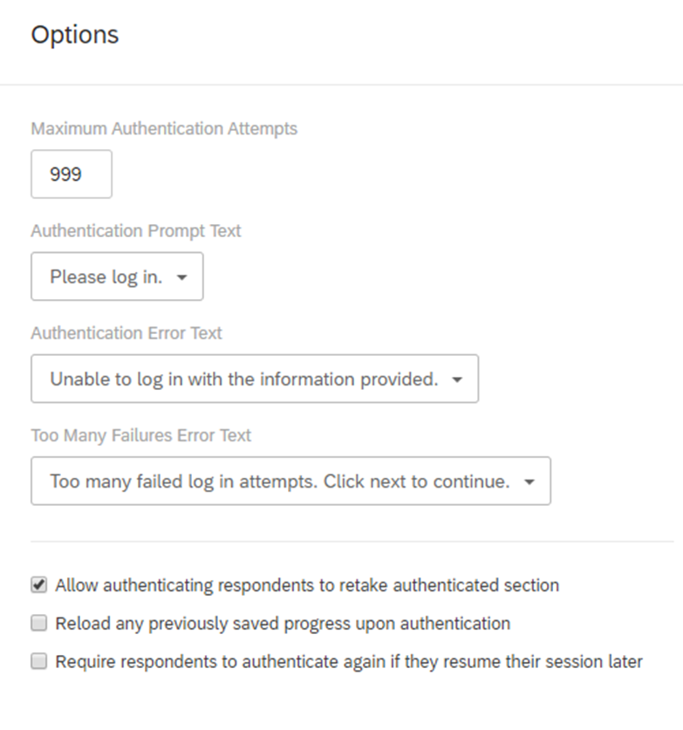

Once the authenticator is set up, we can then set embedded data fields based upon the above the authenticated contact list! To do this, create an embedded data block after the authenticator and select ‘add from contacts’. Choose your contact list and ensure that the correct data fields are being imported. In the below figure, I import the data from my contact list collected from a previous survey (see section 2 of this document).

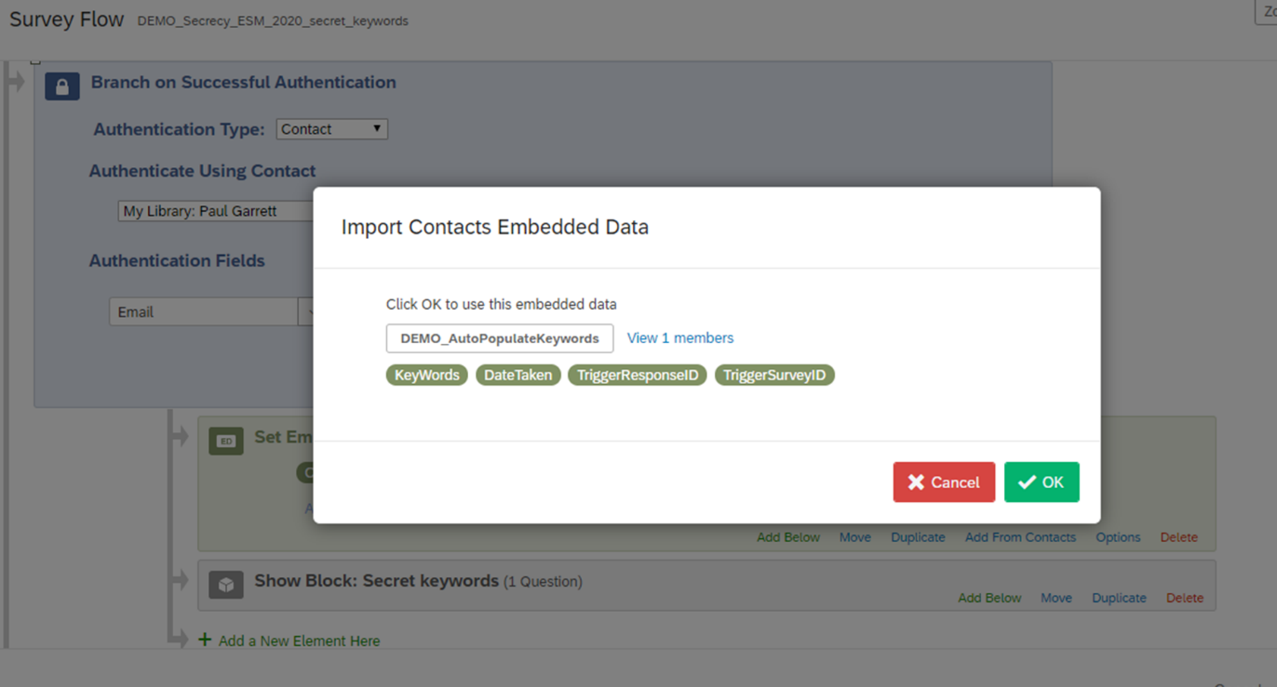

Now our embedded data field ‘KeyWords’ is being defined for each participant and authenticated by their email address. The result looks something like this:

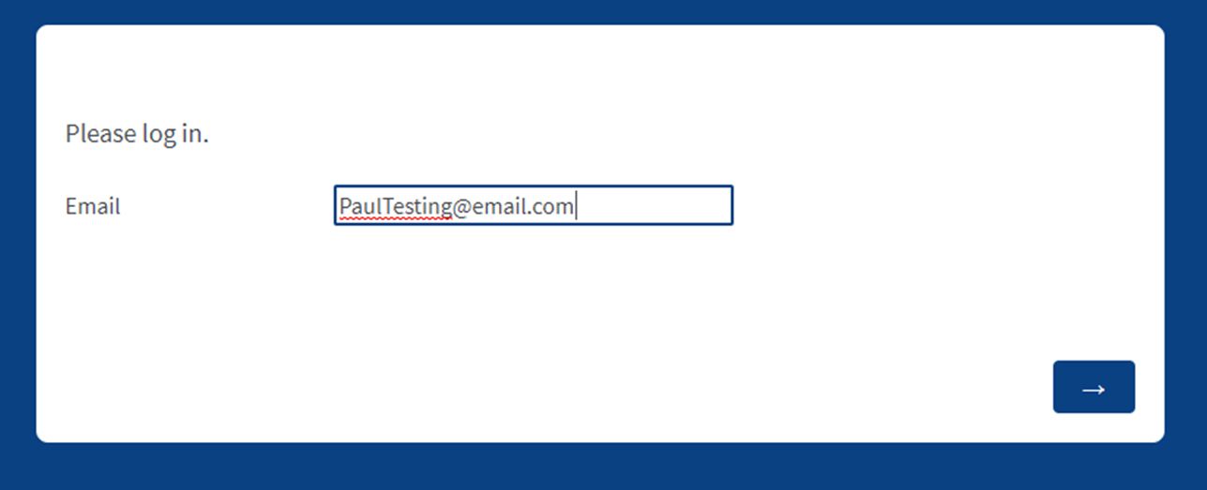

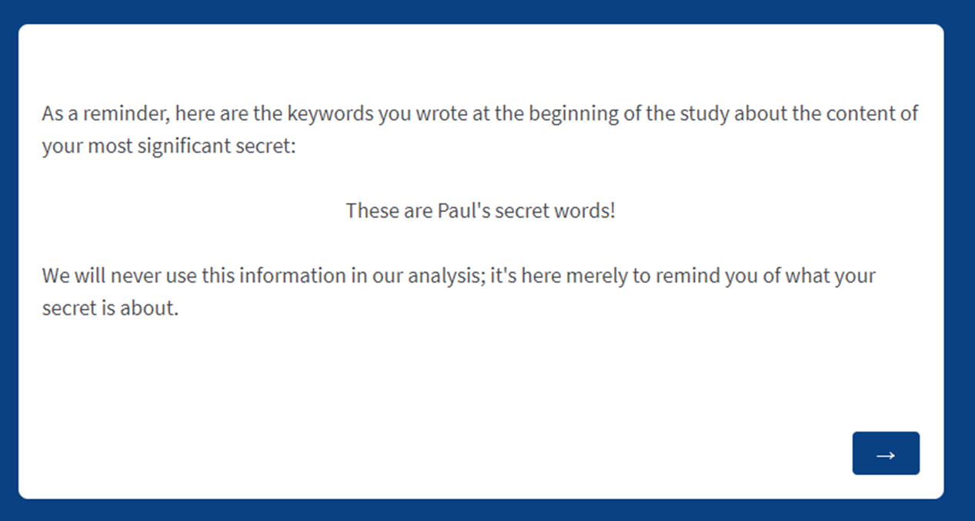

And that’s it, you’re good to go.